Chapter 2

The Global Environment and Operations Strategy

**Background**

Of all the chapters in the book, this one has the most references to global operations. Depending on the instructor’s preferences, he or she could delve further into global issues and, for example, present some operations practices prevalent in different countries of the world. For the strategy sections of the chapter, it is important to emphasize that these are decisions that firms make that use *operations* to earn and keep business (as opposed to, say, an advertising campaign). Picking a strategy may seem trite to some students, but it important to emphasize that all 10 OM decisions will be geared toward the designated strategy.

**Class Discussion Ideas**

1. When describing slide 2-61 showing the OM Strategy/Issues during different stages of the product life cycle, it can be a useful break to stop and ask students to identify examples from the past of when demand significantly outpaced production—i.e., the existence of “fad” items. Examples might include certain video games, hybrid vehicles, Furbies, Tickle Me Elmo dolls, Cabbage Patch dolls, or even pet rocks from the 1970s.

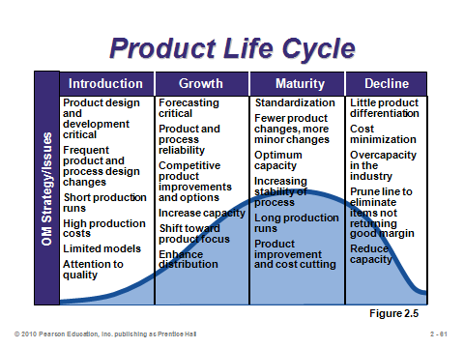

2. For instructors that want to expand treatment of global operations issues, Chapter 2 is probably the place. One way to do that is to have discussion on aspects of operating in some of the largest or most impactful economies around the world, for example, Japan, Germany, China, India, and South Korea. Input from foreign students can be particularly useful here; in fact, instructors may want to ask foreign students to prepare a five-minute talk on their respective countries (potentially for extra credit). Certain cultural differences if tactfully presented can add some humor here. As one of many examples, Frank Perdue’s chicken slogan, “It takes a strong man to make a tender chicken,” was translated into Spanish as, “It takes an aroused man to make a chicken affectionate.”

**Active Classroom Learning Exercises**

1. Have the students split up into small groups to attempt to identify a company (different than ones listed in Figure 2.4 on page 70) that fits into each of the 10 different strategies listed. Have each student group report some or all of its ideas to the whole class. They should support their position with references to specific actions, policies, or events that demonstrate why their opinion makes sense.

2. Have the students split up into small groups to conduct a SWOT analysis of their favorite restaurant or retail store. (Make sure that each group examines a different business.) Have each student group report its analysis to the whole class.

3. Pick an industry and ask the students to think about managing a brand new firm trying to join the industry. What strategy should their firm follow? Then ask the students to find someone else in the class with a different opinion—and each should then try to convince the other why their strategy is best. Take a poll at the end to see which strategy seems to dominate.

**Company Videos**

1. *Strategy at Regal Marine (5:27)*

Some of the key mission statement features for this family-owned business are discussed, including (1) creating best-in-class products with value, quality, and satisfaction; and (2) operating with integrity, honesty, and character. The firm employs a differentiation strategy, manufacturing distinctive and high-value luxury boats. One important means for implementing that strategy is to use very high-caliber dealers (120 of them in 40 countries) that will represent the products in a proper manner. Despite a primary strategy of differentiation, Regal Marine also continues to focus efforts on cost reduction to stay afloat in this highly competitive industry.

Prior to showing the video, the instructor might ask the students to think about ways that the 10 OM decisions for this firm support its differentiation strategy. A follow-up discussion might explore how some of those decisions might differ if the firm had pursued a cost leadership strategy. Finally, the instructor might ask students to identify the pros and cons for this size of a family-owned company to pursue a differentiation strategy in a highly competitive industry. For example, a lack of economies of scale compared to larger competitors might make cost leadership difficult; however, branding is key when pursuing a differentiation strategy, and that also takes a serious amount of effort and investment to establish in the marketplace—presumably more challenging for smaller firms.

2. *Hard Rock Cafe’s Global Strategy (9:36)*

At the time of the video, Hard Rock had 106 locations in 38 countries and was looking to expand further, particularly in Europe, Latin America, and parts of Asia. Hard Rock’s branding has been a key reason why it can so easily enter new markets in new countries. Considerations when expanding into a new market include: political risk, currency risk, social norms, brand fit, social costs, and business practices. The second half of the video focuses on the idea of creating a service “experience.” Seventy percent of Hard Rock’s customers are tourists seeking a special memory. Not only is each restaurant full of rock-and-roll memorabilia, but each piece comes with an associated story. Every restaurant has something from Elvis, the Rolling Stones, the Beatles, and Jimmy Hendrix. Restaurant designers try to link older generation musicians with newer ones. Restaurant layout also enhances the rock-and-roll experience, going beyond being a museum to include live and energetic features (e.g., audio-visual, staff members, and bar) that produce significant sensory stimulation. Finally, a key strategy for merchandise sales is the use of location-specific logos. Despite having an e-commerce presence, a shirt with a city name can only be purchased at that city’s Hard Rock Cafe, so tourists will buy these otherwise common-looking logo shirts to advertise/reflect about their trip to that city.

Prior to showing the video, the instructor could ask the students to identify features that make Hard Rock Cafe different from other restaurants, even other themed restaurants. Afterwards, discussion could revolve around the operations decisions that support these features. A different discussion could focus on the international location decisions. What are important considerations for Hard Rock as compared to other businesses (say, manufacturing facilities)? For example, low-cost labor does not seem to even be a consideration for Hard Rock. A follow-up question might ask the students how they, if put in charge of new restaurant location decisions for Hard Rock, would find out if residents and tourists of a potential new city would be interested in that kind of restaurant.

**Cinematic Ticklers**

1. *Gung Ho, (Michael Keaton and Gedde Watanabe), Paramount Pictures, 1986*

At the beginning of the movie, Michael Keaton’s character travels to Japan to meet with the executive board of a Japanese automotive factory. He presents as a typical American might, while the Japanese businessmen sit in silence. The American leaves the meeting thinking that he blew the presentation.

A second set of scenes can be clipped together to illustrate some of the differences in Japanese vs. American business practices. The scenes are exaggerated to create humor, but they contain some true differences (for example, company uniforms, morning exercises, zero defect policies, strict worker absentee policies, etc.).

2. *The Simpsons Season 3: “Burns Verkaufen Der Kraftwerk,”20th Century Fox Video, 2003 (1991-1992)*

A German company purchases the Springfield power plant, and Homer ends up being the only worker let go. There’s a funny scene where Homer daydreams about living in Germany, “The Land of Chocolate.”

**Presentation Slides**

INTRODUCTION (2-1 through 2-11)

Slides 8-11: These Boeing slides (Global Company Profile) can be presented to emphasize the truly global nature of the company’s supply network—as a precursor to the discussion about global issues.



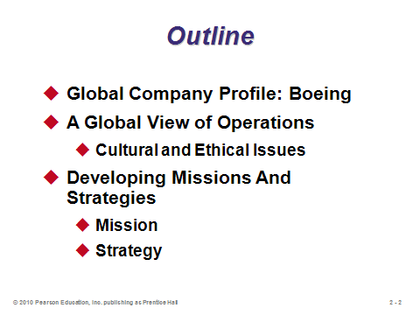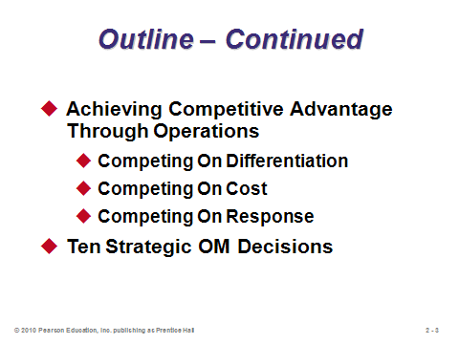

**2-1 2-2 2-3**

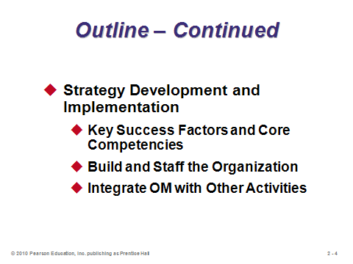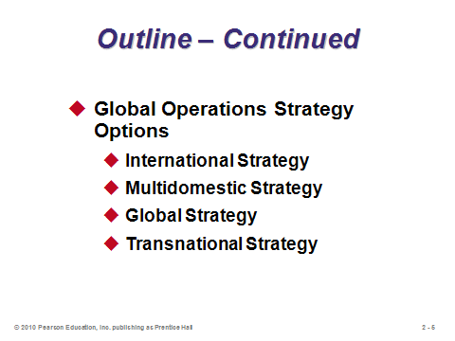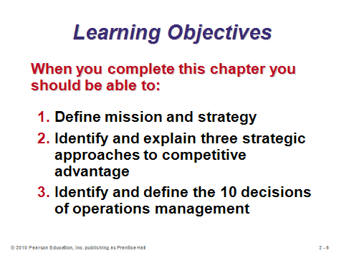

**2-4 2-5 2-6**

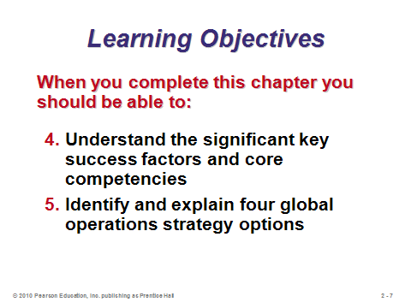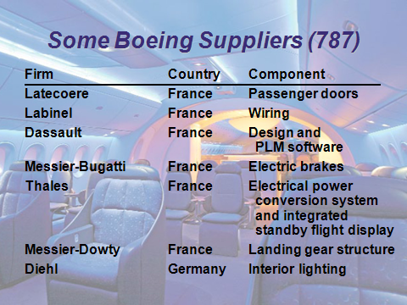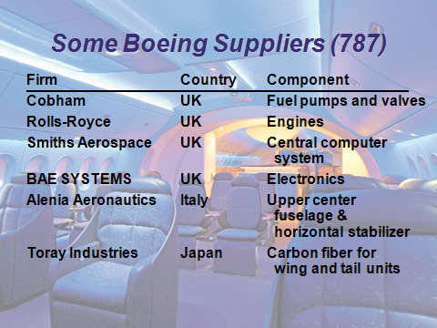

**2-7 2-8 2-9**

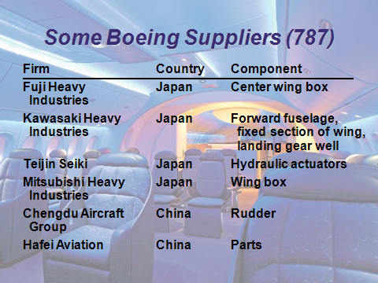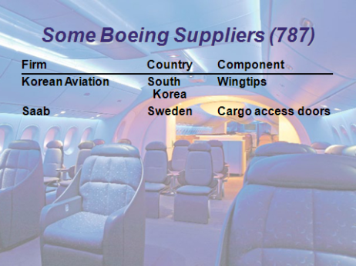

**2-10 2-11**

A GLOBAL VIEW OF OPERATIONS (2-12 through 2-29)

Slides 12-13: These slides present five examples of companies that are hastily extending their operations globally with innovative strategies.

Slide 14: This slide shows the steady growth of world trade over time, with no sign of decline on the horizon.

Slides 15-16: These slides provide examples of well-known firms and the large percentages of sales and assets, and in some cases workforce levels, based outside of their respective home countries.

Slides 17-23: The “Reasons to Globalize” slide (Slide 17) seems particularly important to cover in this chapter, and it is followed by specific discussion on each of the six reasons in Slides 18-23. Slide 18: A very common reason to globalize is to reduce costs, especially labor costs or tariff costs. The numbers can be hard to ignore: for example, saving $10 per hour per worker with 40-hour workweeks (52 weeks per year) and 1000 workers represents a savings in excess of $20 million annually. The agreements and organizations identified in Slide 18 represent ways in which firms can receive preferential tariff treatment. Slide

19: Low labor cost is not always the primary draw as firms sometimes locate to areas containing particular expertise in whatever they are producing. Slide 20: Locating close to customers has not only delivery and customer service benefits, but it also allows the firm to gain a better understanding of the local culture, customs, tastes, and sensitivities. Slide 21: International firms inevitably learn about opportunities for new products and services; also, they may be able to sell maturing products longer in less developed countries. Slide 22: Not all great ideas come from one place—internationalization provides access to great ideas from around the world. Slide 23: Great employees are attracted to firms that offer more worldwide employment opportunities, as well as better insulation from unemployment.

Slides 24-25: These slides are useful for discussing global location decisions. Slide 24 emphasizes that managers must become aware of cultural differences, and they should adjust their expectations and management styles accordingly. Slide 25 identifies some of the many factors that may need to be considered in global location decisions.

Slides 26-29: These slides represent a nice exercise in perhaps dispelling pre-conceived notions about parent companies and home countries of certain products. Student participation can be solicited here.

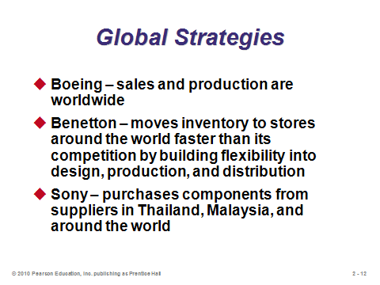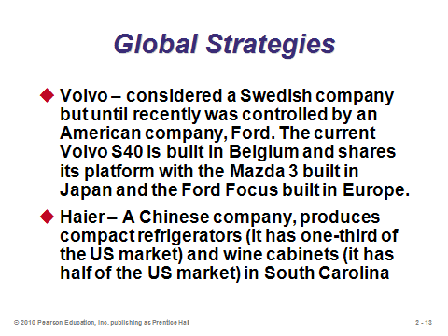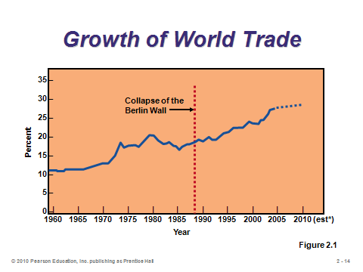

**2-12 2-13 2-14**

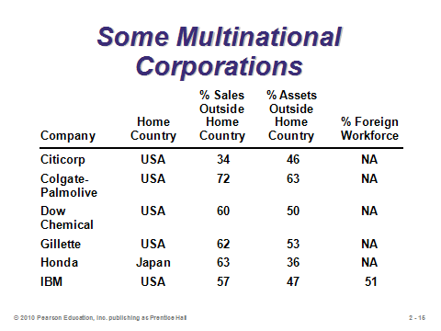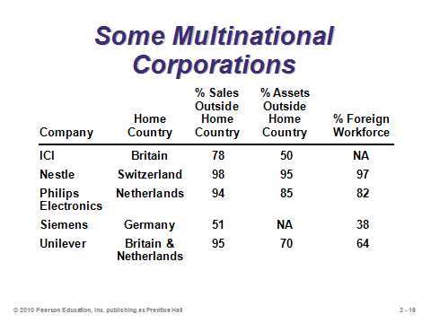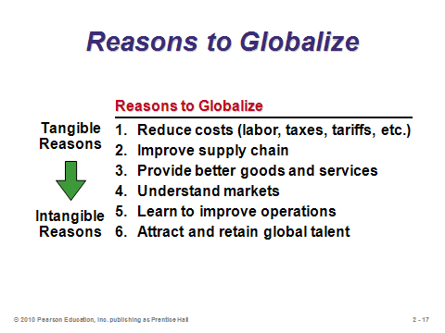

**2-15 2-16 2-17**

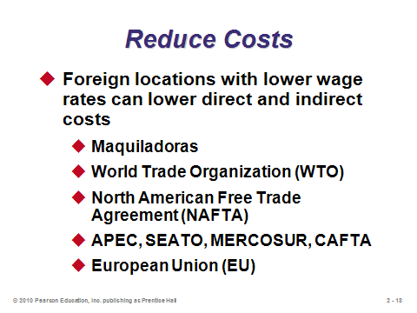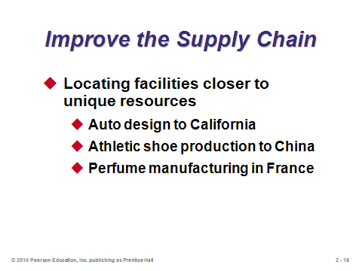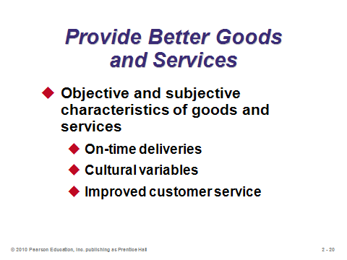

**2-18 2-19 2-20**

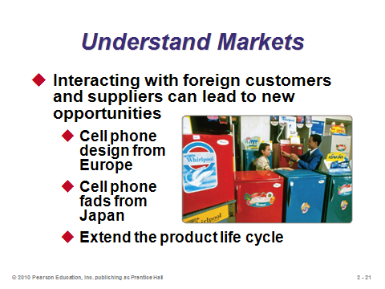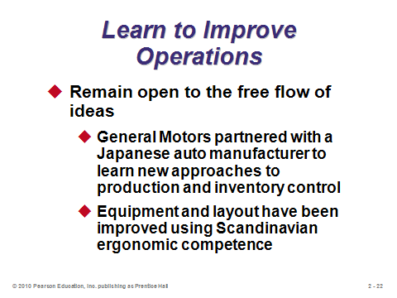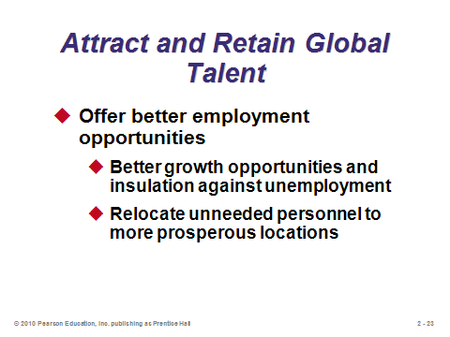

**2-21 2-22 2-23**

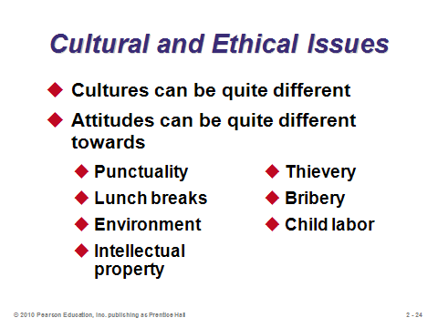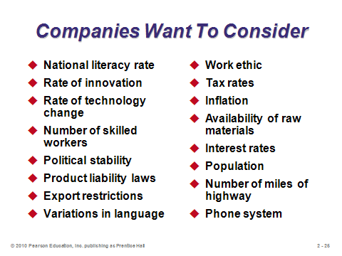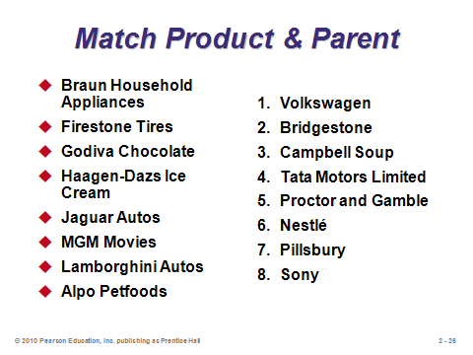

**2-24 2-25 2-26**

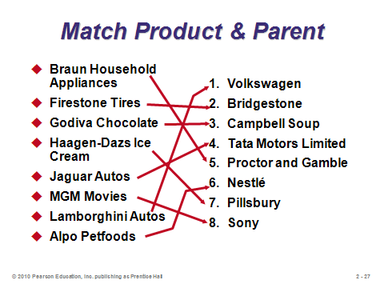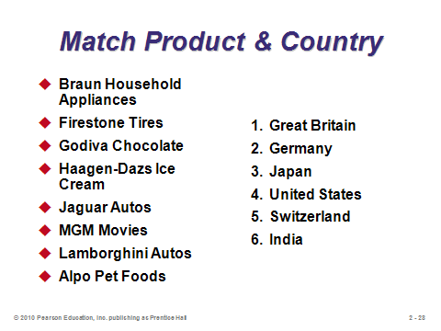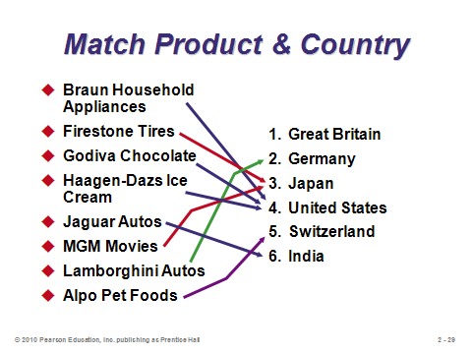

**2-27 2-28 2-29**

DEVELOPING MISSIONS AND STRATEGIES (2-30 through 2-41)

Slides 30-31: An organization’s mission is its purpose—what it will contribute to society. Its strategy is more specific—it represents an action plan to achieve the mission.

Slides 32-34: These slides (Figure 2.2) present examples of three corporate mission statements.

Slide 35: This slide suggests that several more considerations than profit maximization play a role in shaping a firm’s mission.

Slides 36-39: These slides (Figure 2.3) present sample missions for a company, the operations function, and major OM departments.

Slides 40-41: Functional areas have their own missions and strategies, which usually are based on higher-level missions and strategies in the organization. A SWOT analysis can help managers identify strengths, weaknesses, opportunities, and threats to shape their strategies.

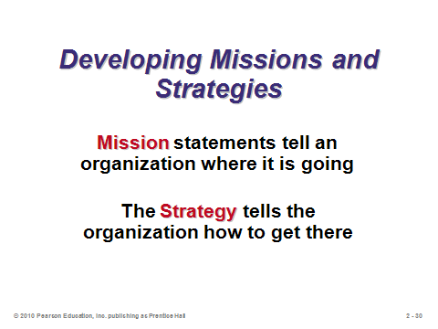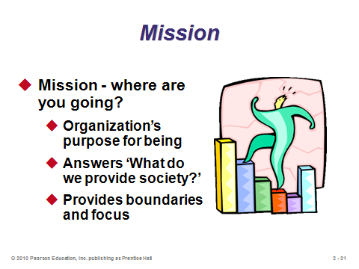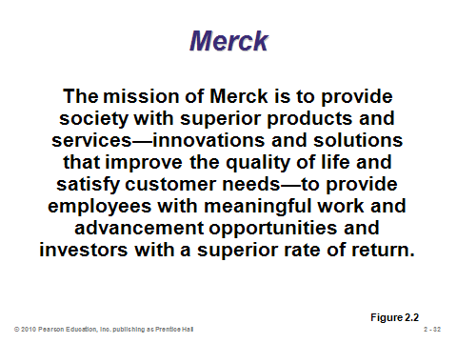

**2-30 2-31 2-32**

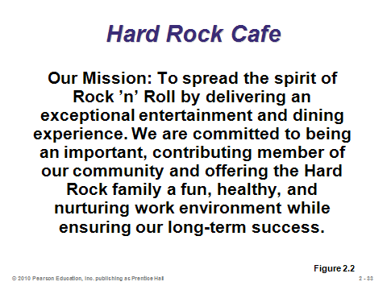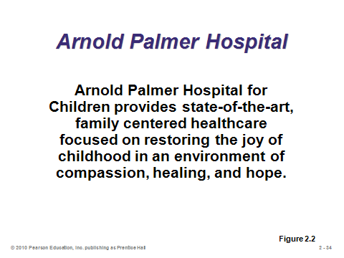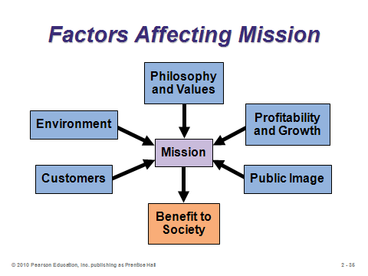

**2-33 2-34 2-35**

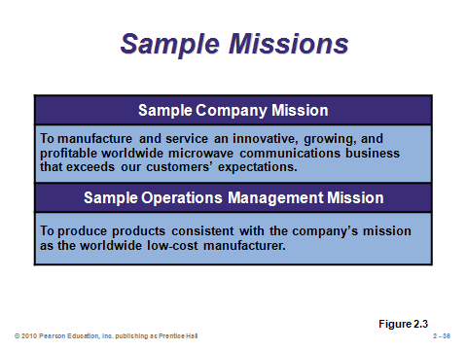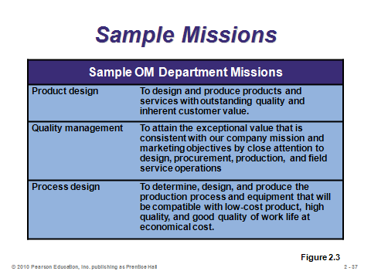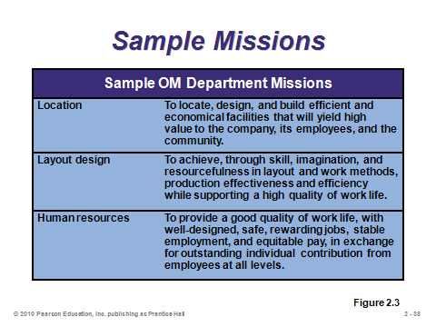

**2-36 2-37 2-38**

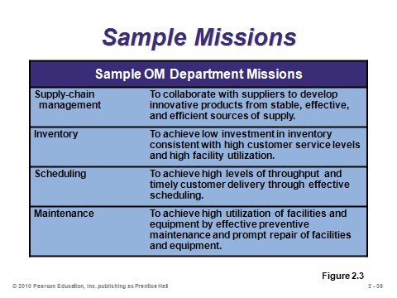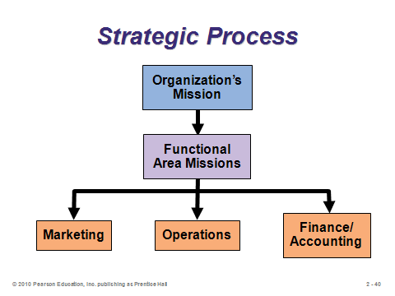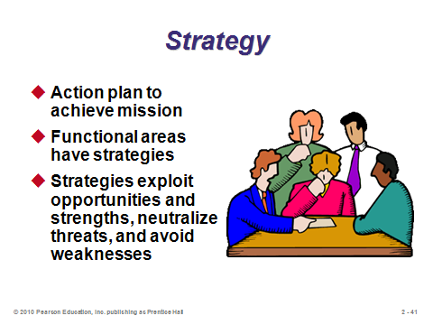

**2-39 2-40 2-41**

ACHIEVING COMPETITIVE ADVANTAGE THROUGH OPERATIONS (2-42 through 2-46)

Slides 42-46: The competitive strategies slides (42-46) are particularly important because an organization’s chosen strategy very much shapes how it approaches the 10 OM decisions. The three major strategies are *differentiation*, *cost leadership*, and *response*. While it may be possible to compete on all three at once, most firms focus on one of these major strategies. Slides 43-45 provide some specific examples of firms implementing these strategies. Slide 46 (Figure 2.4) provides some additional examples, and it emphasizes that firms can achieve competitive advantage via their *operations* function, by applying the 10 OM decisions to implement one or more of the competitive strategies.

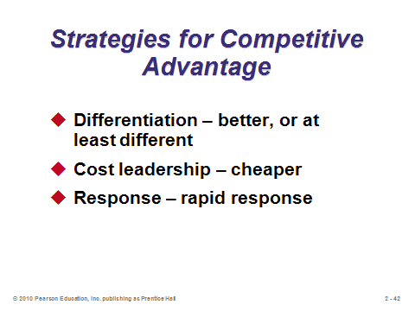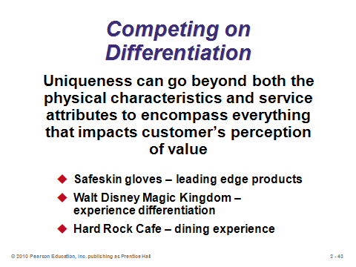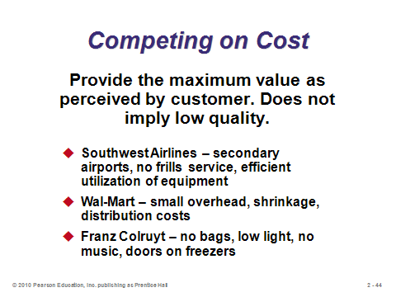

**2-42 2-43 2-44**

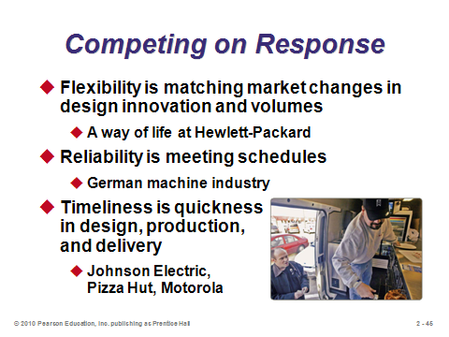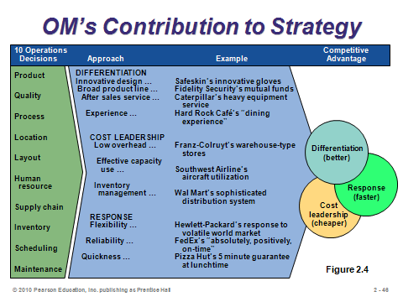

**2-45 2-46**

10 STRATEGIC OM DECISIONS (2-47 through 2-58)

Slide 47: The 10 operations decisions first encountered in Chapter 1 are re-addressed here. The text is structured around these 10 decisions.

Slides 48-51: These slides (from Table 2.1) illustrate how the differences between goods and services influence the ways in which the 10 OM decisions are applied.

Slide 53: This process design slide is a variation on the classic product-process matrix by Hayes and Wheelwright. It’s an important one to discuss, especially the relatively new strategy of *mass* *customization*.

Slides 54-58: From Table 2.2 in the text, notice how the 10 OM decisions are altered to build two distinct strategies within the same industry.

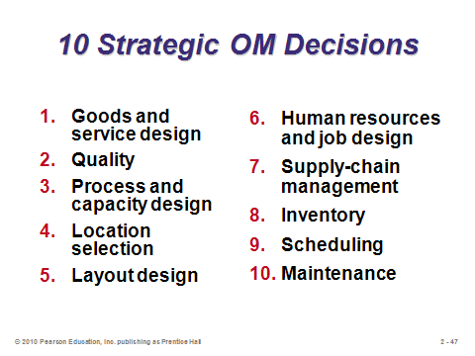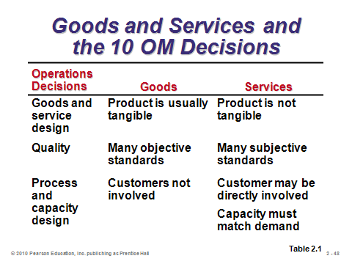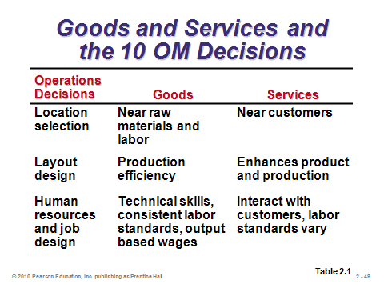

**2-47 2-48 2-49**

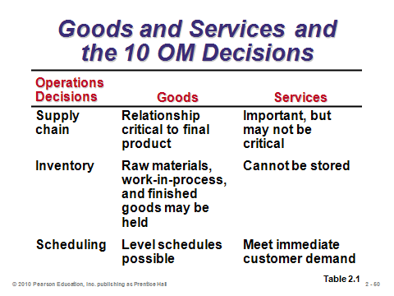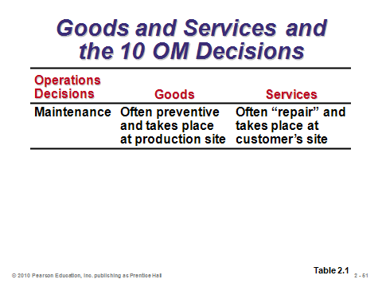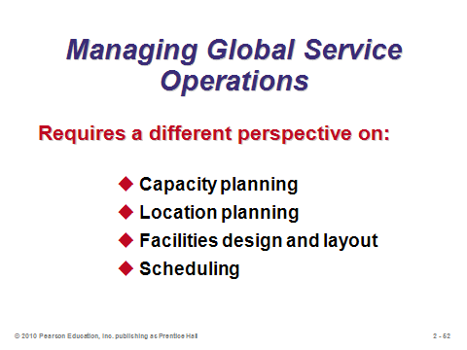

**2-50 2-51 2-52**

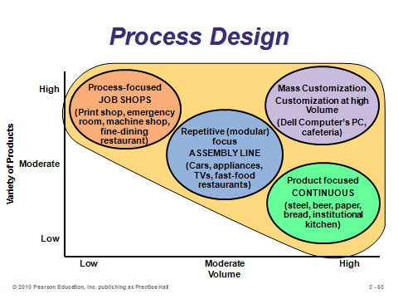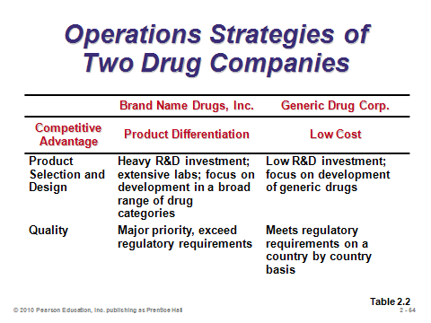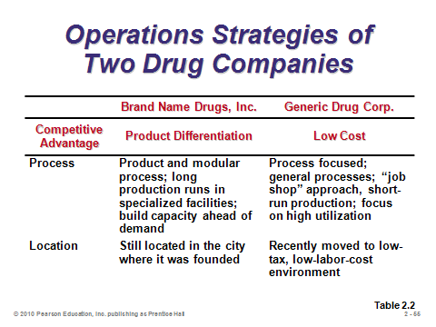

**2-53 2-54 2-55**

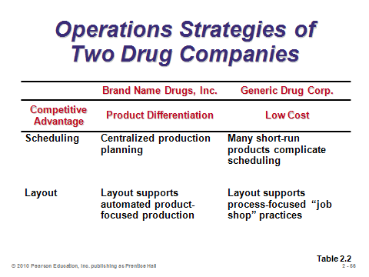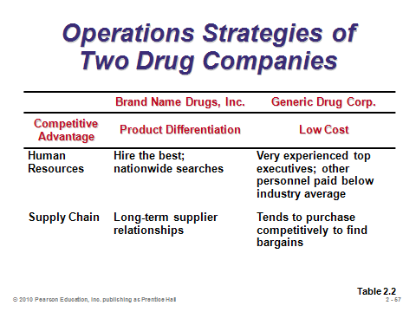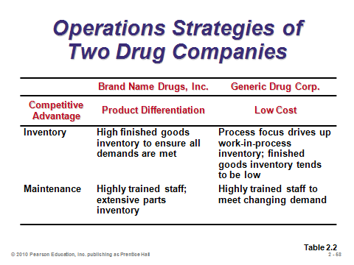

**2-56 2-57 2-58**

ISSUES IN OPERATIONS STRATEGY (2-59 through 2-61)

Slide 59: This slide identifies some alternative perspectives that may be helpful prior to establishing and attempting to implement a strategy. A *resources view* is a method that managers use to evaluate the resources at their disposal and manage or alter them to achieve competitive advantage. *Value-chain analysis* is a way to identify those elements in the production/service chain that uniquely add value. *Porter’s five forces model* is a method of analyzing the five forces in the competitive environment: immediate rivals, potential entrants, customers, suppliers, and substitute products. Because the firm operates in a system with many external factors, constant scanning of the environment is required. Finally, strategies need to be dynamic to deal with constant internal and external change.

Slides 60-61: These slides (from Figure 2.5) are valuable, especially to emphasize that the point in the product life cycle helps to determine the areas of emphasis for operations management.

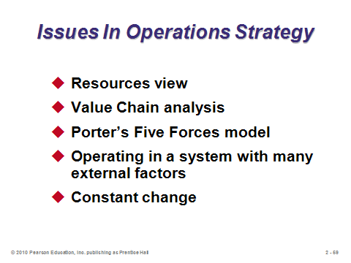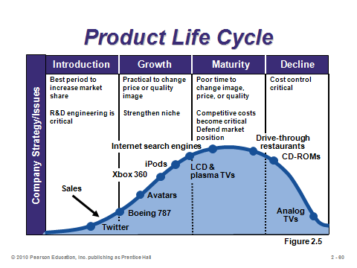

**2-59 2-60 2-61**

STRATEGY DEVELOPMENT AND IMPLEMENTATION (2-62 through 2-72)

Slide 62: A SWOT analysis is a formal review of the internal strengths and weaknesses and the external opportunities and threats. It represents an excellent model for evaluating a strategy.

Slide 63: This slide (Figure 2.6) illustrates the strategy development process, in which SWOT analysis plays a key role.

Slide 64: *Key success factors* are those activities that are necessary for a firm to achieve its goals. Once identified, the next step is to group the necessary activities into an organizational structure. That structure then needs to be staffed with personnel who will get the job done right. The operations function is most likely to be successful when the operations strategy is integrated with other functional areas of the firm, marketing, finance, HR, IT, etc.

Slide 65: The 10 OM decisions typically include the key success factors. This slide (Figure 2.7) identifies potential key success factors for marketing, finance, and operations. The 10 OM decisions provide an excellent initial checklist for determining key success factors and identifying core competencies within the operations function.

Slides 66-72: These slides present Figure 2.8 from the text in an eye-appealing, dynamic manner. An *activity map* is a graphical link of competitive advantage, key success factors, and supporting activities. This figure presents an example activity mapping of Southwest Airline’s low-cost competitive advantage.

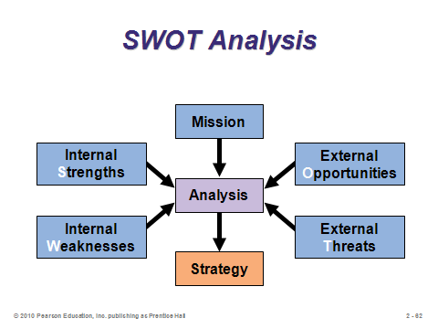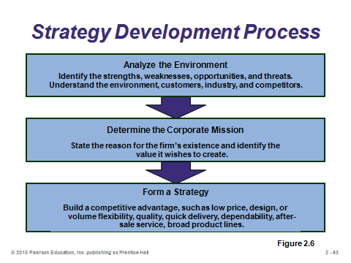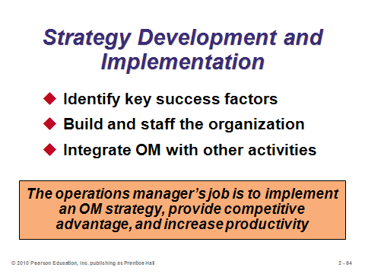

**2-62 2-63 2-64**

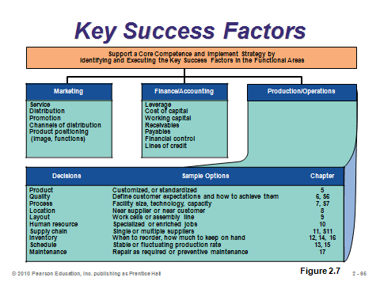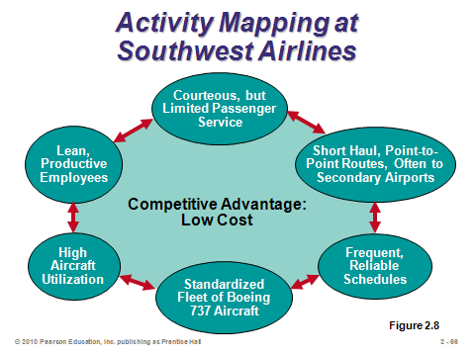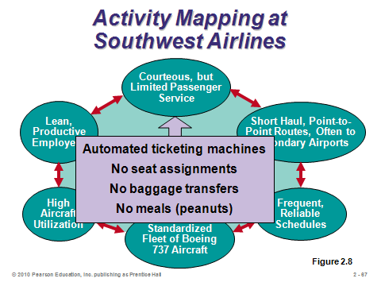

**2-65 2-66 2-67**

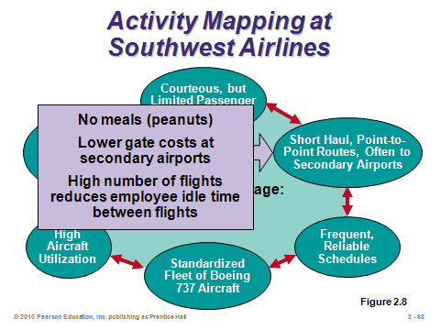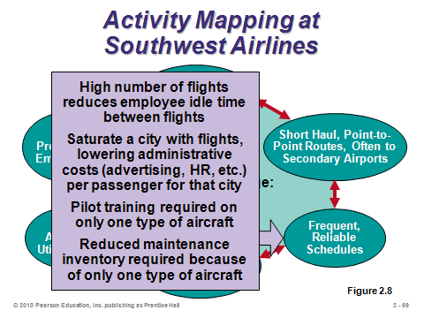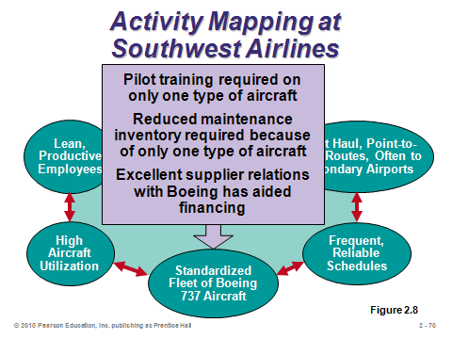

**2-68 2-69 2-70**

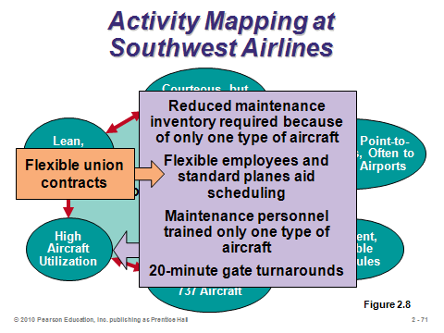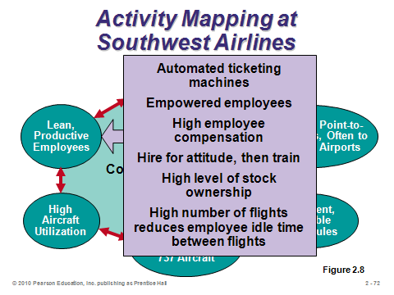

**2-71 2-72**

GLOBAL OPERATIONS STRATEGY OPTIONS (2-73 through 2-81)

Slides 73-80: These slides present Figure 2.9 from the text in an eye-appealing, dynamic manner. The figure places the four international operations strategies on a graph with *local responsiveness* on the *x*-axis and *cost reduction* on the *y*-axis. A *transnational strategy* has the potential to pursue all three operations strategies (differentiation, low cost, and response). Such firms can be thought of as “world companies,” whose country identity is not as important as its interdependent network of worldwide operations.

Slide 81: This slide is an interesting way to end the chapter discussion by presenting a ranking of the most corrupt countries.

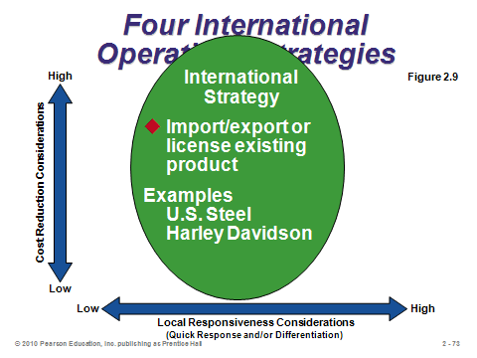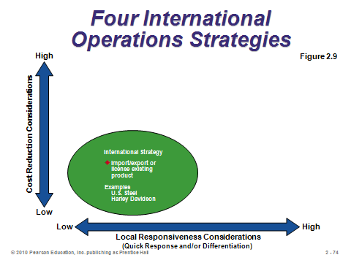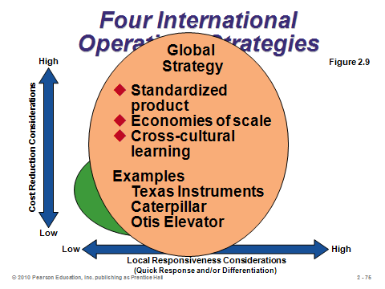

**2-73 2-74 2-75**

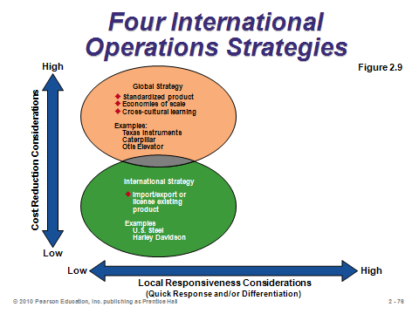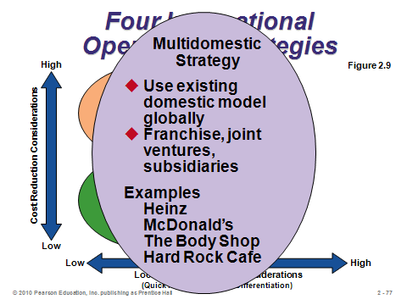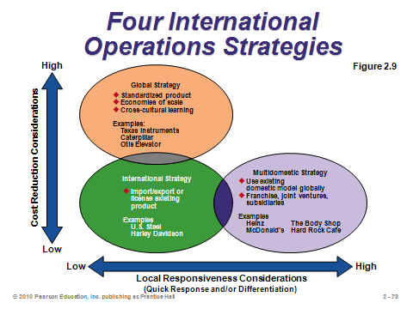

**2-76 2-77 2-78**

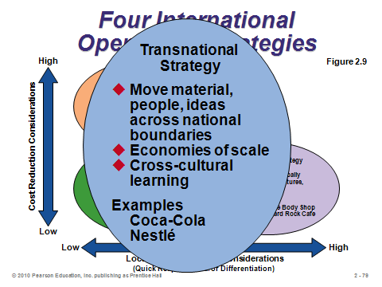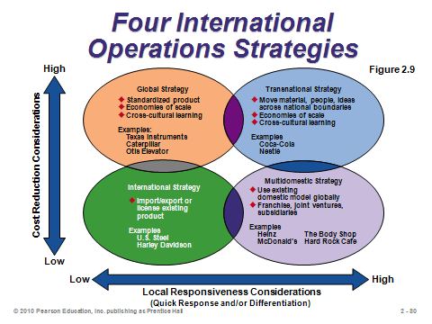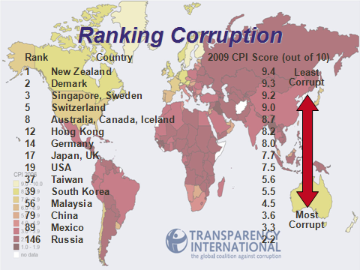

**2-79 2-80 2-81**

**Additional Assignment Ideas**

1. Ask students to prepare for class by visiting several company web sites and, for each company, locating the company mission and printing a copy of the mission to bring to class. The students should also be asked to, if possible, determine the strategy used by the company to achieve its published mission.
2. Look at the web sites for two different companies and determine how they operate in the global business environment. Students should try to address the following questions:

* How is a global strategy in evidence from their web site?
* What sort of global operations strategy do they seem to be adopting; international, multidomestic, global, or transnational?
* Does their facility location reflect their global strategy?
* How much of their business is done globally?
* How does their work force reflect their global strategy?

**Additional Case Studies**

Internet Case Study (www.pearsonglobaleditions.com/heizer)

* *Motorola's Global Strategy*: Focuses on Motorola's international strategy.

Harvard Case Studies (http://harvardbusinessonline.hbsp.harvard.edu)

* *Eli Lilly and Co.: Manufacturing Process Technology Strategy—1991* (#692056) Manufacturing purses comparative advantage in an industry where R&D is the primary competitive advantage.
* *Fresh Connections* (#600-022): Investigates how to structure operations to take advantage of the continued growth in the home meal replacement market.
* *Hitting the Wall: Nike and International Labor Practices* (#7000047) Nike must deal with a spate of alarmingly bad publicity regarding wages in developing countries.
* *Hewlett-Packard: Singapore (A)* (#694035) Product development issues when source and recipients of knowledge are separated both geographically and culturally.
* *Komatsu, Ltd* (#398-016): Describes strategic and organizational transformations at Komatsu, a major Japan-based producer of construction equipment.
* *McDonald's Corp.* (#693028) Changing environment and competition forces McDonald's to rethink its operations strategy.
* *Southwest Airlines — 1993 (A)* (#694023) Provides insights into Southwest’s strategy, operations, marketing, and culture.
* *Toys "R" Us Japan*: (#796-077): Documents Toys "R" Us difficulties as it enters the Japanese toy market.
* *Lenzing AC: Expanding in Indonesia* (#796-099): Presents the issues surrounding expansion in a foreign country.

Richard Ivey School of Business (http://cases.ivey.uwo.ca/cases/pages/home.aspx)

* *Daikin Industries* (#9B04D018): The president of Daikin Industries Residential Air Conditioning Shiga Factory was confronted by the prospects of an unseasonably cold summer, at a time when the Shiga Factory had large quantities of its products in inventory in anticipation of strong summer sales. The president must decide whether to reduce the number of models, build a lower-cost factory outside Japan, or exit the business.

**Internet Resources**

|  |  |
| --- | --- |
| Business Policy and Strategy, Division of the Academy of Management | www.aom.pace.edu/bps |
| European Union | http://europa.eu/ |
| International Trade Administration | www.ita.doc.gov |
| Manufacturing Strategies, maintained at Cranfield University | www.cranfield.ac.uk/som |
| Transparency International maintains a Bribe Payers Perception Index (PBI) and a Corruption Perception Index | www.transparency.de  www.globalcorruptionreport.org |
| World Bank | www.worldbank.org |
| World Economic Forum | www.weforum.org |
| World Trade Organization | www.wto.org |

**Other Supplementary Material**

Videos

1. *Wall Street*

This movie illustrates very different corporate missions between the established company and the one trying to take it over.